***PRACTICA 6: “Buscando a mis amigos los pingüinos”***

***Cortes Garcia Oscar Francisco***

***Repox:* /^\[\+672\s[0-9]{10}\]\s(Skipper|Kowalski|Cabo|Rico)/**

[+672 7473935113] Rico

[+672 5345009331] Skipper

[+672 8766764155] Kowalski

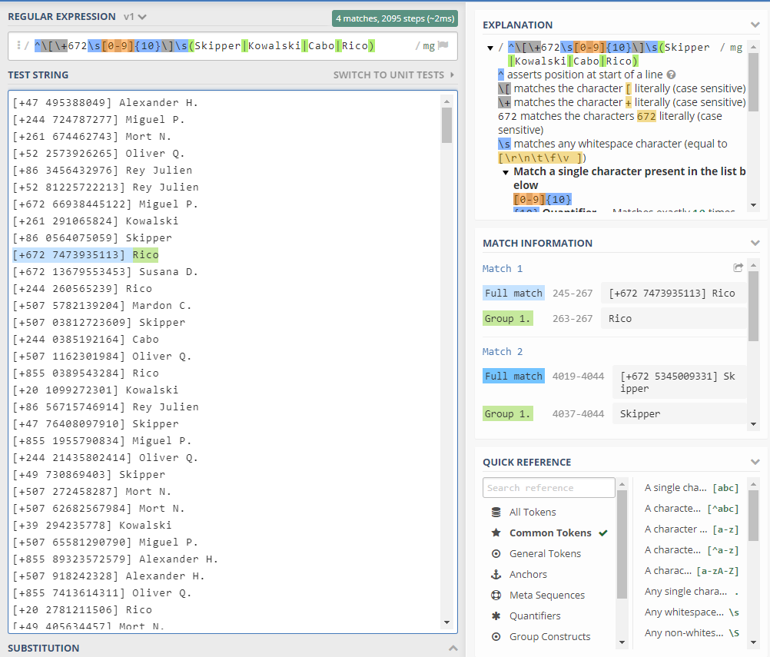 [+672 5085533408] Cabo

https://regex101.com/r/74k8CM/2